WEEK 3

# Personal Portfolio Website using HTML and CSS

Aim: To build a personal portfolio Website page

Languages used: HTML, CSS and JavaScript

Software Used: Visual Studio

During week 3 I have built my very own personal portfolio website which tells a bit about myself and also the skills I posess.

This time the coding and the website building complexity about the same as the previous restaurant I built. We included responsive elements and the website was just not a single page but consisted of multiple pages just like the previous website project.

As always my mentor Rocky Sir helped a lot in the queries and errors during the project building. He played an important role solving my errors which were a lot more than last time.

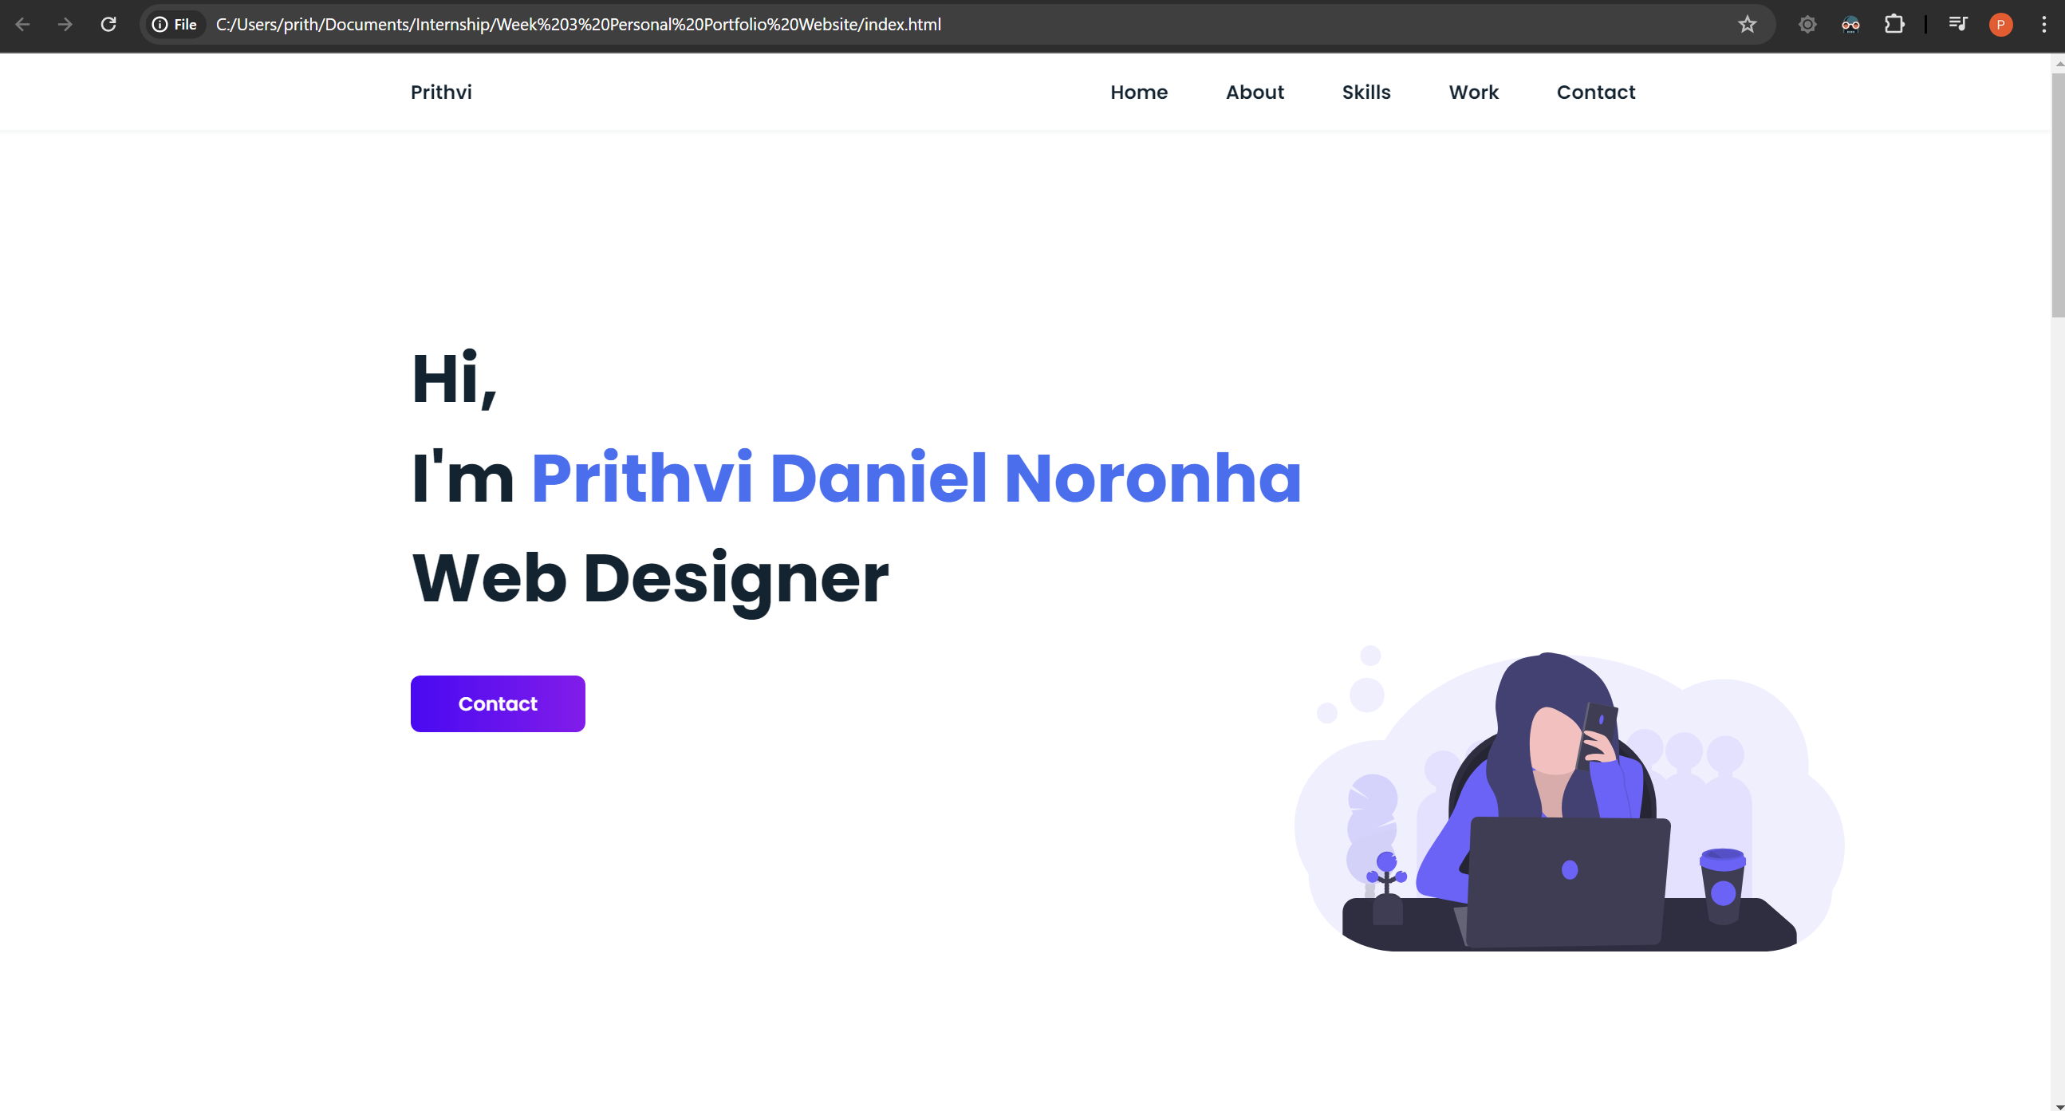

This is the starting page of my personal portfolio website.



When clicking on each of the titles available it takes you to the respective section of the website which is a convenient feature for the visitor.

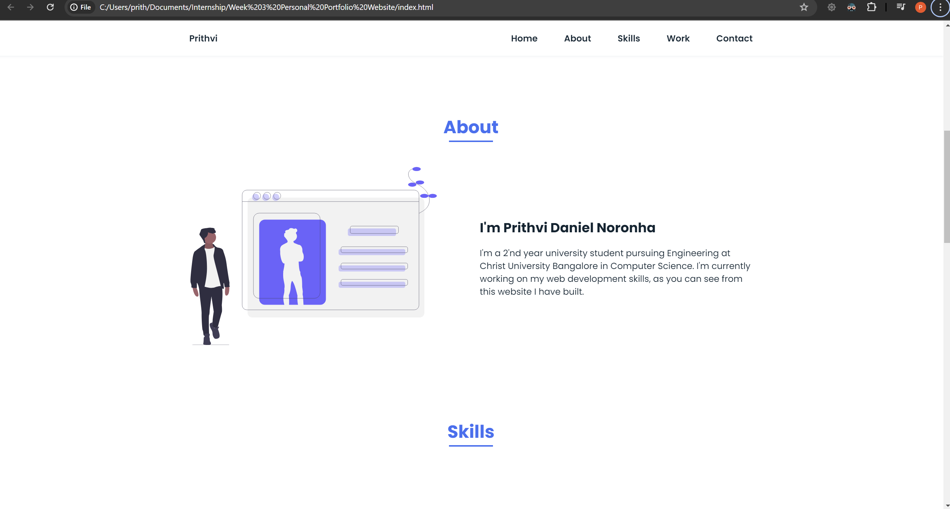

The about section describes in a few words who I am and what is my area of expert. All the pages and elements are responsive and while scrolling down from the main page the about section has a slide in animation.

Below is the skills section of the website.

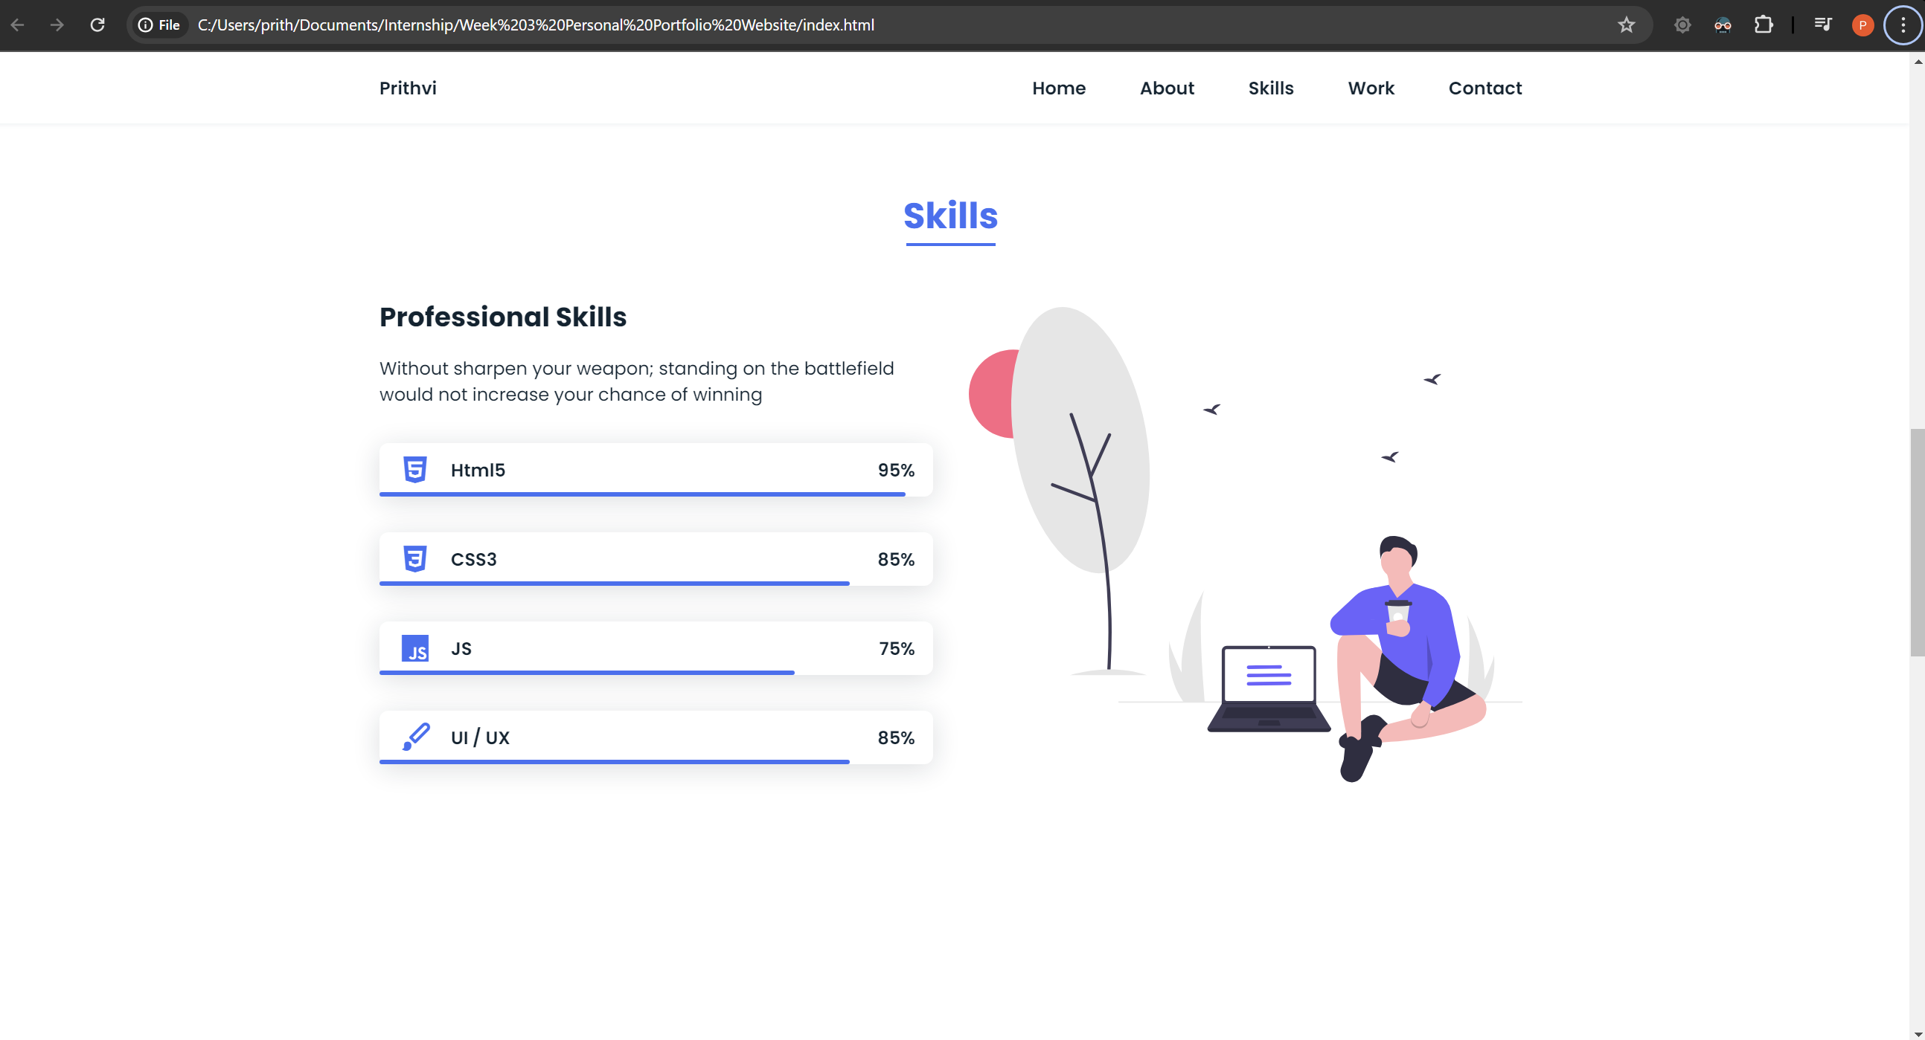

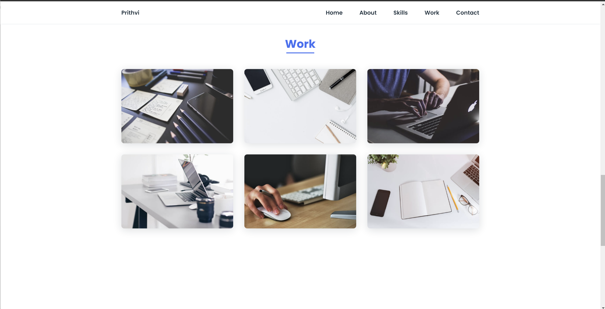

This section is to include my personal works and projects that I have built or worked on. Although these are just images which are responsive when hovered upon, I intend to create them to hyperlinks that direct the person viewing directly to the project or website that I have worked on.

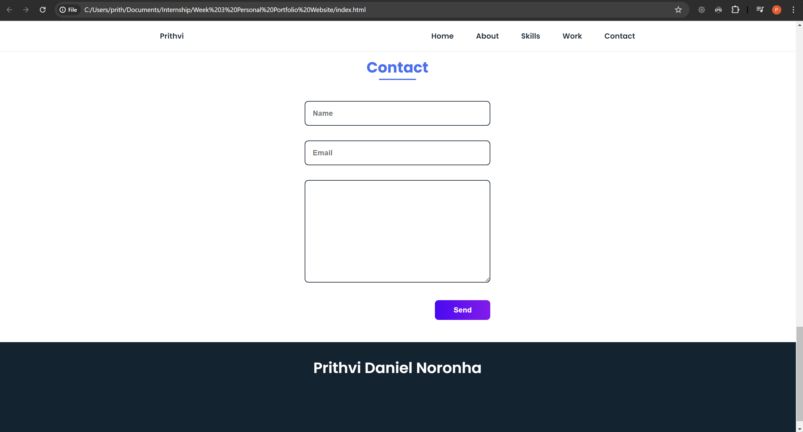

The last section of the website is a way to contact me and if you have any queries u can drop it in the box.

The code and all elements used has been uploaded separately in a folder in the drive.